I would suggest program profiling, in market there are a few open source Java Profiler tools such as VisualVM and JConsole.

Timing measure is 1 of the feature in Java Profiler.

**Profiling Architecture** (taken from https://www.usenix.org/legacy/events/coots99/full_papers/liang/liang_html/node3.html)

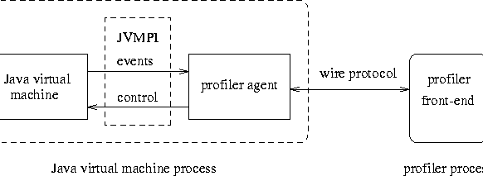

|  |  |
| --- | --- |
| **Component** | **Function** |
| JVMPI (JVM Profiling Interface) / JVMTI (JVM Tools Interface) | -provides hooks to profilers, for trapping events like calls, class-load, unload, thread enter leave  -currently JVMPI is known as JVMTI |
| Profiler Agent | -responsible for the communication between the Java virtual machine and the profiler front-end |

Note: The reason for the separation of the profiler front-end is to prevent the profiler front-end from interfering with the application.